*Strictly Summer*
“Beach Week” Weds 4th & Fri 6th August
Beach theme week – come and dance in beach wear – swim gear and shorts etc! (and persuade your parents to take you to the beach after!!)

Wednesday 4th August (Beach)
Juniors (6-12 years)
10.30am-2.30pm

Acro
Ballet Technique Class
Singing and Lyrical Dance
Street/Commercial
Stretch & Body Con
Speed Tap

Friday 6th August (Beach)
Juniors (6-12 years)
9.15am-1.00pm
Ballet Pop
Singing
Lyrical
Beach Games!

Seniors (13+ years Major level) 4.30-8.45pm
Free Lyrical
Speed Tap
Contemporary
Body Con
Commercial

“Crazy Week” Weds 11th & Fri 13th August
Crazy week – including crazy hair day, crazy sock day and crazy scavenger hunt!

Weds 11th August – CRAZY HAIR DAY!
Juniors (6-12 years)
10.30am-2.30pm
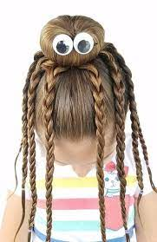
Drama
Ballet Technique Class
Lyrical Dance
Stretch & Body Con
Repertoire
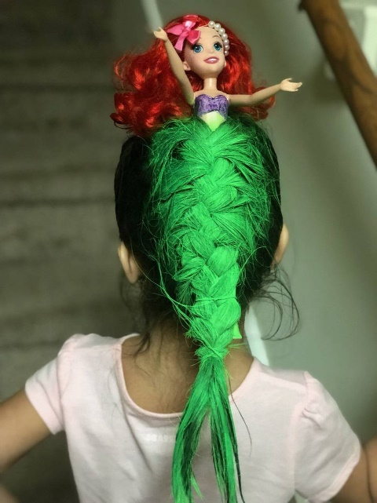
Speed Tap

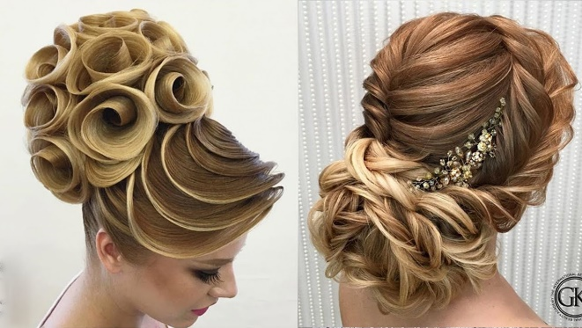

Friday 13th August – CRAZY sock day!
Juniors (6-12 years)
9.15am-1.00pm
Make a Dance Advert for AAX!
Strictly Juniors!
Junior Pro Show – learn
a routine from a pro show!
Crazy Scavenger Hunt!

Seniors (13+ years Major level) 4.00-8.45pm
Partner work / Lyrical Jazz
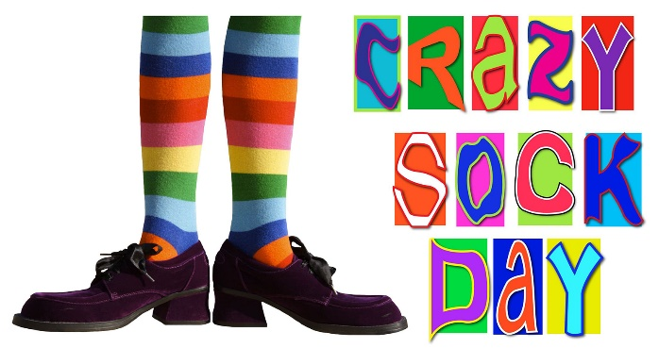
Strictly Seniors!
Speed Tap
Contemporary
Body Con
Commercial
“Party Week” Weds 18th – Fri 20th August
Party theme week – come and dance with party accessories – watch out for the surprise party games etc! (and persuade your parents to take you for a party pizza after class!!)

Weds 18th August (Let’s Party!)
Juniors (6-12 years)
9.30am-1.45pm

Acrobatic Arts
Musical Theatre
Ballet Technique
Stretch & Body Conditioning
Singing & Lyrical Dance
Street/Commercial

Friday 20th August (Let’s Party!)
Juniors (6-12 years)
9.15am-1.00pm
Commercial
Strictly Juniors!
Junior Party Routine
Junior Party Games!

Seniors (13+ years Major level)
4.00-8.45pm

Partner work / Strictly Routine
Make a Music Video
Speed Tap
Contemporary
Body Con
Commercial
“Talent spotting Week” PUPILS ONLY
Weds 25th & Fri 27th August
Prizes for showing us how talented you are!! Surprise us and we will surprise you!!

Wednesday 25th August (*Talent)
Juniors (6-12 years)
9.30am-1.45pm
Acrobatic Arts
Musical Theatre
Ballet Technique
Stretch & Body Conditioning
Singing & Lyrical Dance
Street/Commercial

Friday 27th August (*Talent)
Juniors (6-12 years)
9.15am-1.00pm
Commercial
Strictly Juniors!
Junior Jazz!
Show us your talent!

Seniors (13+ years Major level) 4.00-8.45pm
Partner work / Strictly Routine
Pro show piece from Babbacombe
Drama
Contemporary
Body Con
Commercial

